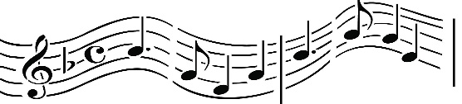
Grand Montgomery Chamber Music Series
(Since 1987)
FREE Concert
Sunday Feb. 23, 2020 at 3:00 P.M.
Garrett Concert Stage at Montgomery Center
36 Bridge Street, Montgomery, NY 12549

Hudson Valley Chamber Players

JOËL EVANS, oboe; MARCIA GATES, flute; CHARLES McCRACKEN, bassoon 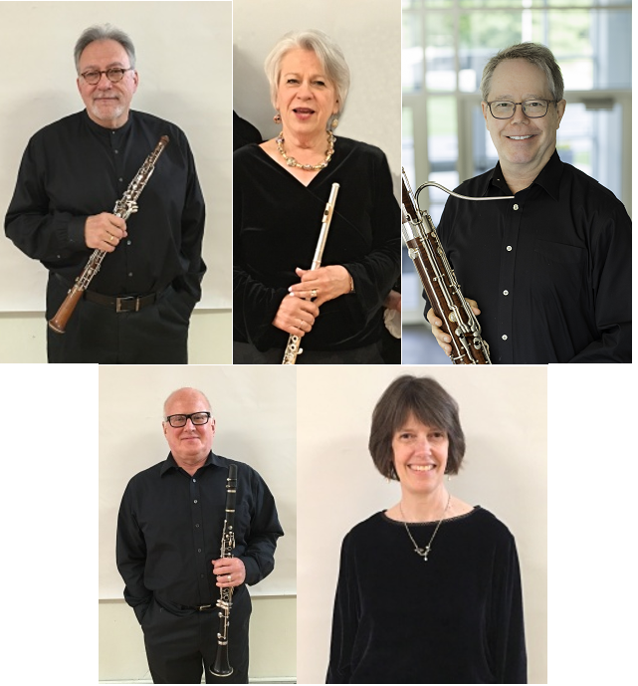
LARRY TIETZE, clarinet; RUTHANNE SCHEMPF, piano.

These concerts are made possible by the generous support of the Village of Montgomery, Orange County Office of Tourism, Orange County Arts Council, Town of Montgomery, Historic Montgomery Association, Recycled Style, Glen Arden, Mike’s Deli, Montgomery Food Mart, Adams Fairacre Farms.
Also, a thanks to Mimoza Vezuli, Barry Plaxen, Eric Hamblin, and Mona Toscano.

Aleksander Vezuli, Artistic Director and Manager
www.montgomerychambermusic.com

